Machine Learning Model

Preprocessing

Data Collection

The dataset was loaded using the pandas library in Python, specifically using the read_csv() function. The independent variables include Hours_Studied, Attendance, Sleep_Hours, Motivation_Level, and Previous_Scores, while the dependent variable is Exam_Score. These variables were selected based on their relevance to student performance.

Data Cleaning

The dataset was checked for missing values and duplicates. Missing values were handled by either removing incomplete rows or filling them with appropriate values. Duplicate records were also removed to ensure data consistency and accuracy.

Treating the Categorical Variables

The dataset contains ordinal categorical variables such as Motivation_Level (Low, Medium, High). These were converted into numerical values using label encoding (e.g., Low = 1, Medium = 2, High = 3). This was necessary because machine learning models require numerical input.

Splitting the Dataset

The dataset was divided into training and testing sets using an 80/20 split. This is important to evaluate the model’s performance on unseen data and avoid overfitting.

Feature Scaling

Feature scaling was not required for Linear Regression, but it was useful for KNN and K-Means because these models depend on the distance between values.

Regression Model

Building the Regression Model

Implement Multiple Linear Regression, Polynomial Regression, Lasso, Ridge, and Elastic Net models. Select the best-fitting model based on evaluation metrics(R-squared). Analyze the model's performance by comparing predicted values with the actual values in the dataset.

Deriving the Regression Equation

The best-fit model was selected based on the highest R² score.

The regression equation is:

Exam_Score = b₀ + b₁(Hours_Studied) + b₂(Attendance) + b₃(Sleep_Hours) + b₄(Motivation_Level) + b₅(Previous_Scores)

Where b₀ is the intercept and b₁–b₅ are the coefficients. Five random records were selected and substituted into the equation to calculate predicted values. A scatter plot was used to compare the observed values with the predicted values. Points closer to the diagonal line show better prediction accuracy.
Classification Model

Classifying the dataset based on the target variable

The target variable was converted into categories based on Exam_Score:

Low: Exam_Score < 65
Medium: 65 ≤ Exam_Score < 75
High: Exam_Score ≥ 75

This allows classification models to predict performance levels instead of exact scores.

Building classification models

Classification models including Logistic Regression, KNN, Naive Bayes, and Decision Tree were implemented. The models were evaluated using Accuracy, Precision, Recall, and F1-score. Among all models, the best classification model was selected based on the highest accuracy score and overall performance.

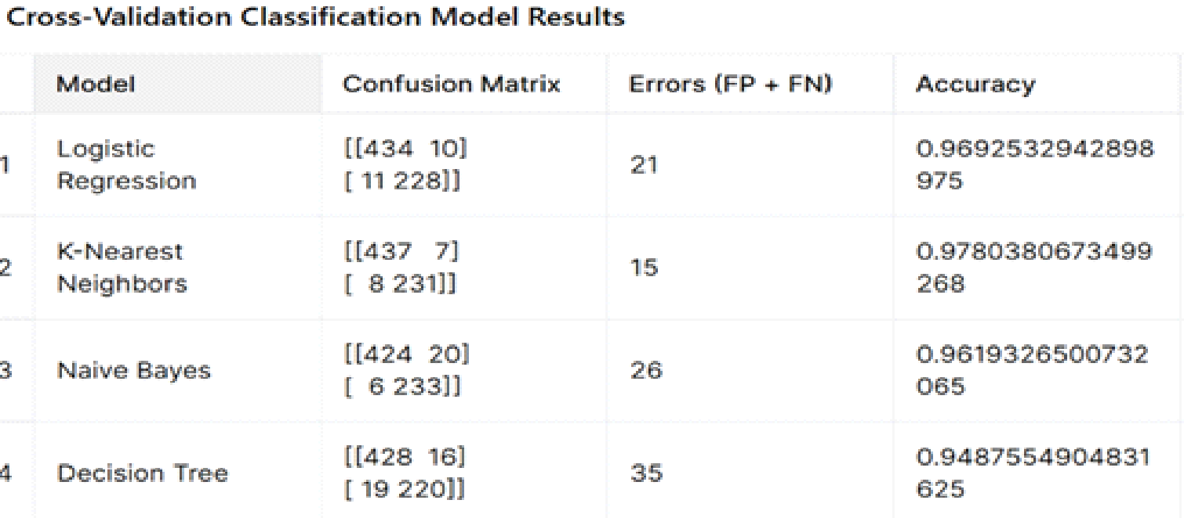

No of elements on the target variable

The number of records in each category was counted to check the distribution of Low, Medium, and High performance levels.

Cluster Analysis

Building the Cluster Analysis

K-Means clustering was applied to group students based on Hours_Studied and Exam_Score because these two variables are easy to visualize in a scatter plot. Three clusters were used to represent different student performance groups.

Strategy Formulation

Cluster 1 (Low Performance): Students should increase study time and improve attendance
Cluster 2 (Medium Performance): Students should focus on consistency and revision strategies
Cluster 3 (High Performance): Students should maintain their current habits and aim for further improvement

Explanation for Decision Tree Graph :

The decision tree graph shows how the model classifies students into Low, Medium, or High performance levels. Each box in the tree represents a decision rule based on the selected variables. This helps explain how the model reaches a prediction instead of only showing the final result.
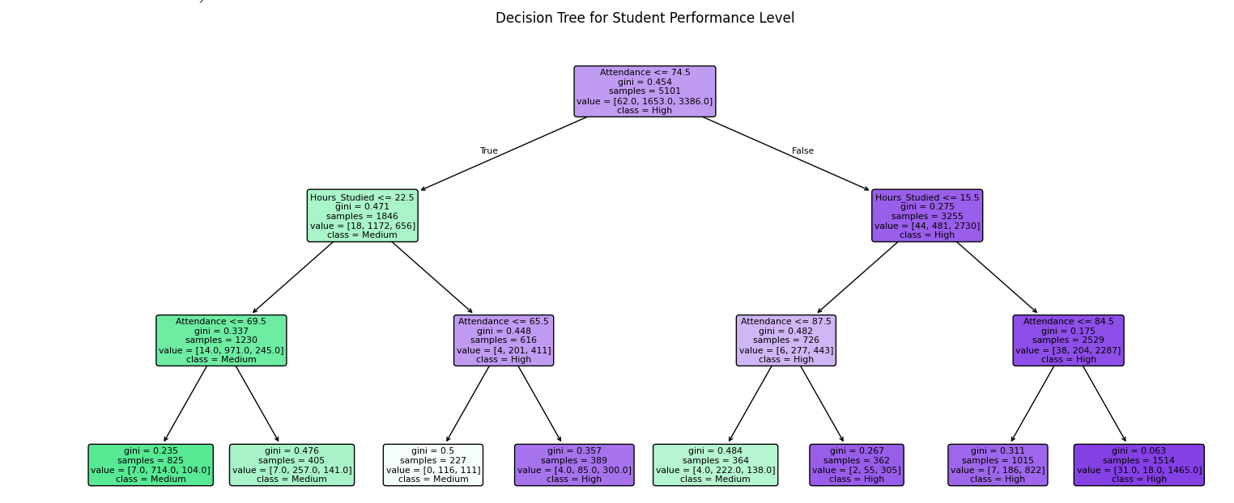

Explanation of Cluster Graph :

The cluster graph shows students grouped based on Hours_Studied and Exam_Score. Each color represents a different cluster. Students in the same cluster have similar study hours and exam scores. This helps identify patterns in student performance.

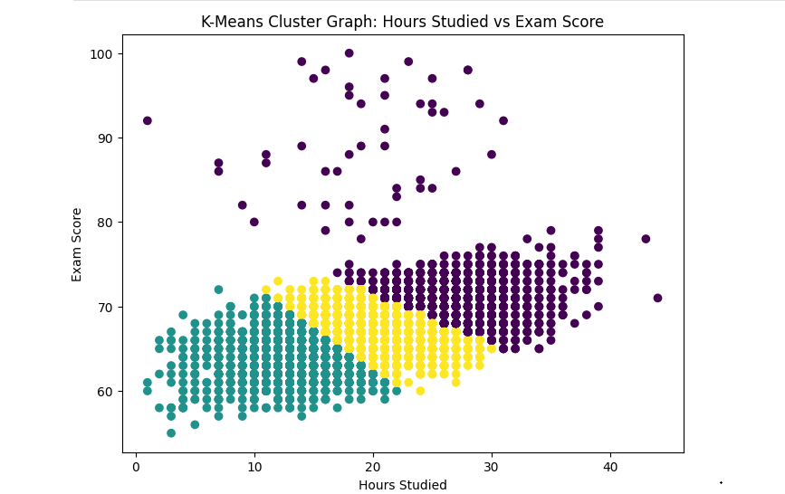

End of Documentation.

